One of the current popular topics regarding Market Approach methodologies is whether median or harmonic mean is the better statistical measure to calculate the revenue and cash flow multipliers of a sample of comparables. Both metrics have their strong points. However, the multipliers they generate occasionally produce values for an appraisal subject that do not appear reasonable. It is fairly common that the value calculated using the median revenue multiplier of a sample of comparables is considerably higher than the value calculated using the median cash flow multipliers. And, at other times, we find that the value calculated using the median cash flow multipliers is considerably higher than value using the median revenue multipliers.

Regression analysis typically overcomes these problems as will be demonstrated below. However, the appraisal industry prefers to use the statistical measures of median or harmonic mean, not because they are superior methodologies, but because they are “an easy sell.” As experts, if we explained to a jury that the median is a “measure of central tendency that represents where the market is,” almost everyone will accept that definition without further explanation. Trying to explain what regression does loses almost everyone, including a few judges who consider regression a form of “voodoo statistics.”

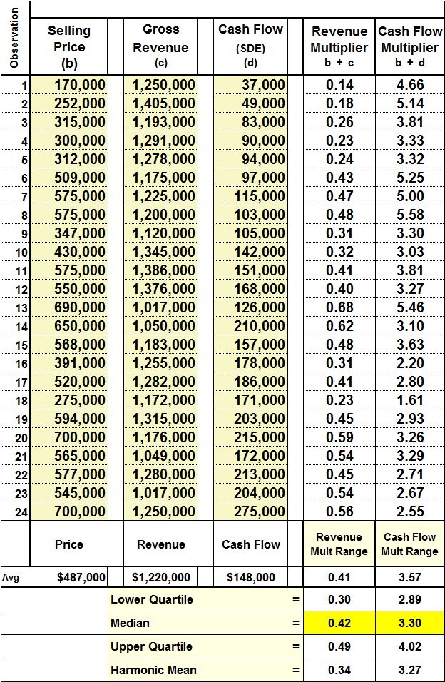

Exhibit I

This article will show the circumstances in which median and harmonic mean fail to produce reasonable values whereas, regression succeeds. More importantly, we will break down regression in the very simplest of terms that not only everyone will understand, but also will agree that it is a superior statistical measurement.

The Problem

We will start with a typical sample of comparables that an appraiser might collect. The exhibit on the left shows 24 companies that were similar to our subject company. Each transaction shows the selling price, gross revenue, cash flow, and its calculated revenue and cash flow multipliers. From the data we can calculate the median revenue multiplier for the whole sample (0.42) and the median cash flow multiplier (3.30). We also note that the average company sold for $487,000, had an average revenue of $1,220,000 and cash flow of $148,000.



Our first example valuation will be for a company that is fairly similar to the average sized comparable in our sample. The subject’s revenue was $1,200,000 and cash flow was $150,000. By using the median revenue multiplier of 0.42 we obtain an estimated value for our subject of $504,000. The median cash flow multiplier produces a value of $495,000. The values from both metrics are reasonably similar and no one would challenge the appraiser for opining a value of $500,000.

Median and harmonic mean begin to have problems when we appraise a company that is an underperformer. Example #2 shows a company with the same revenue as example #1 but, its cash flow is only $85,000, far less than the average of our sample. The median revenue multiplier of 0.42 produces the same value as the more profitable company in example #1, so we know that isn’t reasonable. The cash flow multiplier of 3.30 produces a value of $280,500, which appears to be too low. If the appraiser decided to use the lower quartile of multipliers, using the justification that the subject is an underperformer, we find the revenue multiplier value was $360,000. Although that value would seem reasonable, given that the more profitable company in example #1 was worth $504,000, the lower-quartile cash flow multiplier produces a value of only $245,650. The appraiser ends up with four values that are so different, how does one know which one is reasonable or, for that matter, if even taking an average is appropriate?

Example #3 shows a company that is far more profitable than the average company in our sample. The resulting cash flow multiplier values for this company are much higher than the revenue multiplier values, exactly the opposite situation that occurred with the unprofitable company in example #2.

The Solution

An appraiser or anyone reading an appraisal is only going to see a valuation for one company. Thus, one will not be aware that the values for an underperforming or over-performing subject are potentially way off the mark when using median or harmonic mean. **Why are the values for companies that are at the opposite ends of the cash flow spectrum so divergent? Answer: Regardless of how profitable the subject company was, it was accorded the same median multipliers gleaned from the sample.**

In other words, median and harmonic mean are one dimensional. The solution is to add another dimension to the analysis.

We begin by adding another column of data to our sample. The column contains the operating profit margins of each transaction (cash flow ÷ revenue).[1] The table has been sorted so that the least profitable companies with the lowest SDE% are at the top and the most profitable companies with the highest SDE% are at the bottom.

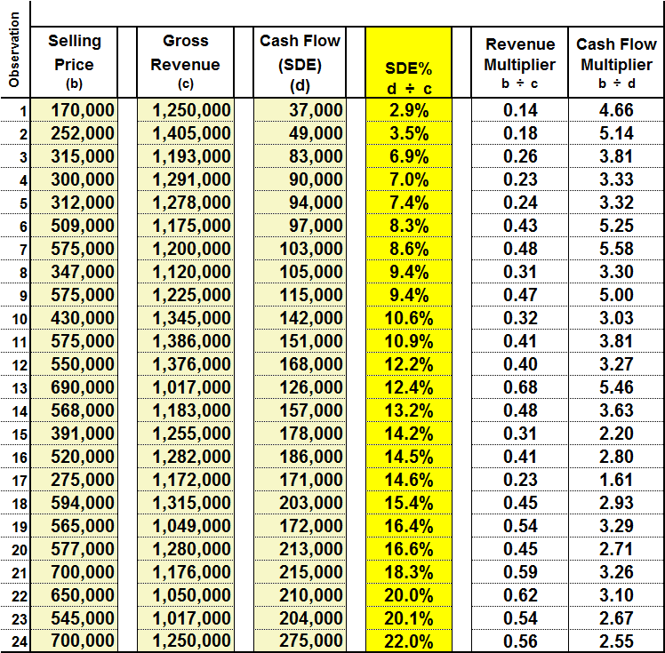

Exhibit II

When we sort the data in this manner, we immediately notice that the companies with the lowest SDE% also tended to have the lowest revenue multipliers. For example, the five companies with the lowest level of profitability (outlined in red) had an average SDE% of 5.5% and their average revenue multiplier was only 0.21. The five most profitable companies had an average SDE% of 18.7% and an average revenue multiplier of 0.54.

**Clearly we can see that the level of profitability was a large factor in a company’s selling price and its resulting revenue multiplier.**

To further dramatize the effect of the level of profitability on a company’s revenue multiplier, we will plot the data from the SDE% column in Exhibit II against the data in the revenue multiplier column.

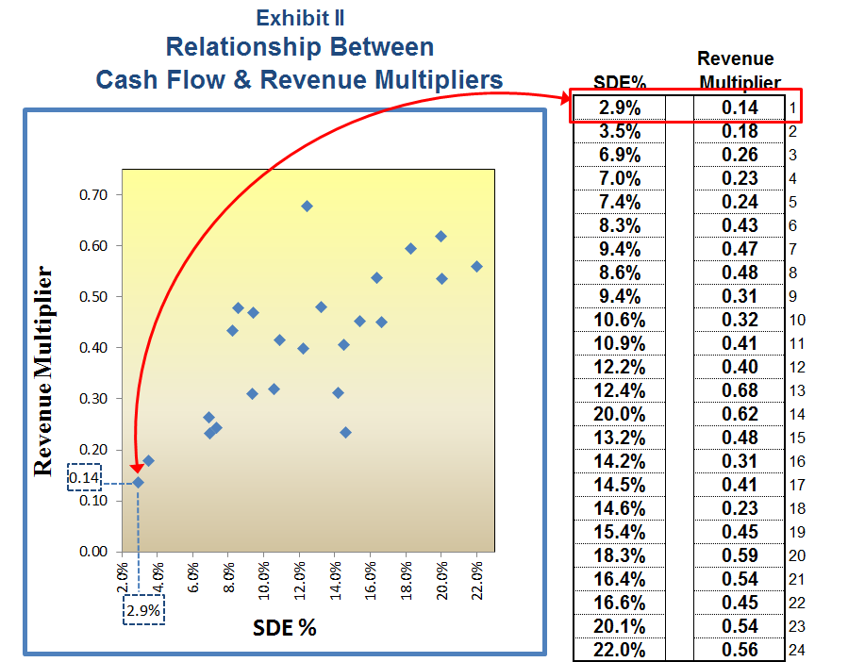

Exhibit III

The horizontal axis in the above exhibit shows the level of a company’s profitability (as measured by SDE%); the farther to the right a company is positioned, the greater the level of its profitability. The vertical axis shows the company’s revenue multiplier; the higher a company is positioned, the greater its revenue multiplier. Each blue dot represents the position of each transaction in our sample given its level of profitability (SDE%) and its revenue multiplier. For example, the blue dot representing transaction #1 on the graph is highlighted in red to show its position given an SDE% of 2.9% and multiplier of 0.14.

When plotting all 24 transactions on the graph we can readily see the strong relationship between the level of a company’s profitability and its revenue multiplier. The companies with greater profitability tend to be positioned farther to the right and higher up on the graph, meaning that the more profitable they are, the higher their revenue multipliers tend to be. One could easily take a ruler and draw a trend line that represents the pattern of the blue dots that we see.

Or, we can use regression to calculate the line with precision. In Exhibit IV, a regression was used to calculate the trend line. The regression line represents the “best fit” to all the blue dots. By “best fit” we mean, if one measured the distance that each blue dot is from the trend line, the total distance of all the blue dots above the line will equal the total distance of all the blue dots below the line. In other words, the total distance of all the blue dots above the trend line minus the total distance of all the blue dots below the line will equal zero.

From the three examples discussed earlier, we determined that the median revenue multiplier for the sample was 0.42. The median line is graphed in red on Exhibit IV. The question is: **which line best represents where the market is?** Clearly, median does not take into account a company’s level of profitability whereas, regression does. As such, median tends to overvalue or undervalue companies that are at opposite ends of the profitability spectrum.

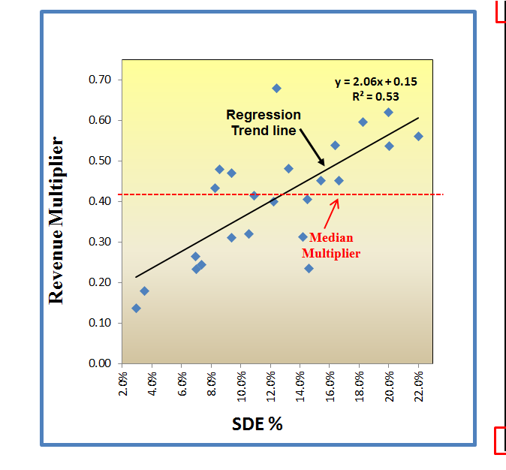

Exhibit IV

The regression will also produce an equation for this trend line that we can use to estimate an appropriate multiplier for a subject given its level of profitability. From Exhibit IV, the equation for the trend line is: y = 2.06x + 0.15. This equation can be redefined for our purposes as: Revenue Multiplier = 2.06 x SDE% + 0.15. By inputing our subject’s SDE% into the equation we can calculate its appropriate revenue multiplier **given its level of profitability**.

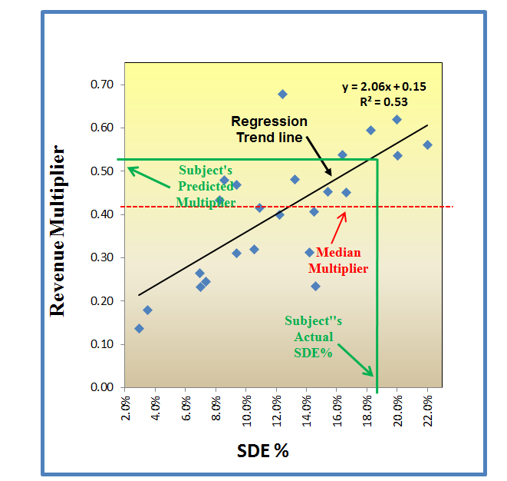

Exhibit V

The third example we discussed earlier showed a highly profitable company with revenue of $1,200,000 and cash flow of $220,000. Its calculated SDE% is 18.3% ($220,000 ÷ $1,200,000). In Exhibit V, we manally plotted its 18.3% SDE% on the graph (in green) to obtain the revenue multiplier of approximately 0.53. We can also calculate the multiplier by using the above regression formula:

2.06 x .183 + 0.15 = 0.53.

The value of the highly profitable company using the regression trend line is: $1,200,000 x .53 = $636,000. The estimated value using the median is: $1,200,000 x .42 = $504,000. Given that nine transactions in our sample had higher levels of profitability and larger multipliers than the median, it is highly likely that the subject would be undervalued by using the median to estimate its multiplier.

Identifying and Removing Outliers

There will always be a few transactions in every sample whose actual selling price was radically different from the price suggested by the regression trend line (i.e. they are significantly out of alignment with the rest of the market.) The regression analysis not only plots a line that best represents where the market is, but also calculates what is referred to as standard error lines. The standard error is a statistical measurement similar to standard deviation. The difference is the standard deviation is a measure of dispersion around a single point in a sample (the mean), whereas, standard error is the same measure dispersion around the regression line. Standard error calculates the upper and lower boundaries between which most of the comparables (68%) in a sample should theoretically fall. Theoretically, 16% of the sample’s transactions should fall above the upper Standard Error line and 16% of transactions should fall below the lower Standard Error line. Those comparables that fall outside these boundaries are companies whose selling prices were so far above or below the rest of the market that the transactional data must be considered flawed. These “outliers,” as they are referred to, will be removed from our sample of comparables.

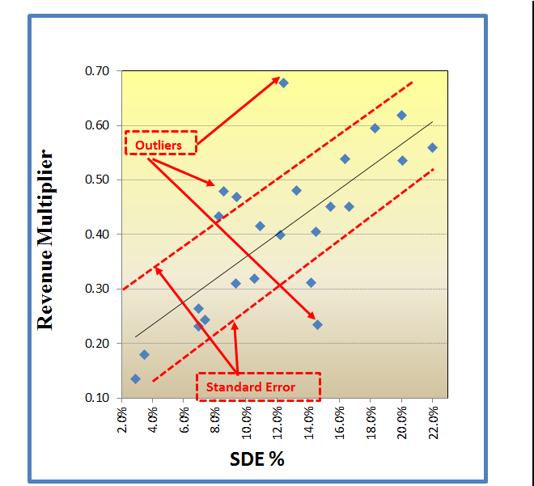

Exhibit VI

The sample in Exhibit III produced a Standard Error of 0.10. That means two lines are drawn parallel to the trend line, the upper-boundary line is 0.10 higher than the trend line and the lower-boundary line is 0.10 lower than the trend line.

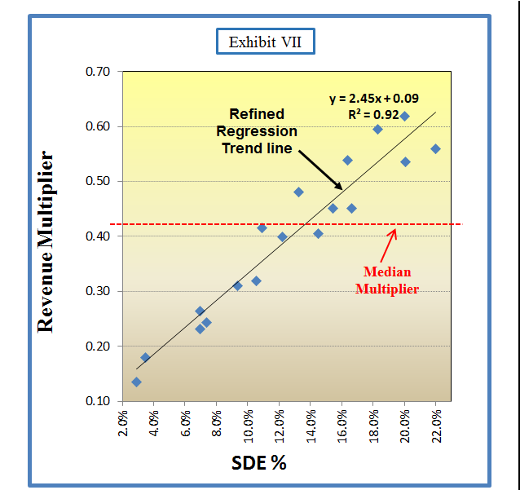

The remaining 68% of the sample, then, are transactions that best define the market where in all probability our subject will fall. Exhibit VI identified six transactions out of the sample of 24 that fell outside the Standard Error boundaries. By removing those outliers, the remaining 18 transactions will generally present a visually compelling argument that the regression trend line is where the market is, not the median. From Exhibit VII we can see that after removing the outliers, the majority of the transactions line up fairly close to the trend line, whereas the median is a constant which is unaffected by the level of a company’s profitability.

After the outliers are removed, a second regression should be performed on the smaller refined sample of 18. The regression equation for the refined sample was: y = 2.45x + 0.09. The resulting multiplier is 0.54, which produced an estimated value of $648,000. Again, the median for this highly profitable company suggested a value of only $504,000.

Cash Flow Multipliers

The logic surrounding the use of regression to predict revenue multipliers makes perfect sense – the higher a company’s level of profitability, the higher its revenue multiplier will likely be. However, this logic is completely the opposite when calculating cash flow multipliers. If we go back to Exhibit II and retrieve the SDE% and cash flow multipliers for each of our 24 transactions, the graph will look like the Exhibit VIII to the left. Amazingly, there is an inverted relationship between a company’s level of profitability and its cash flow multiplier! In other words, **the greater the level of a company’s profitability, the lower its cash flow multiplier.**

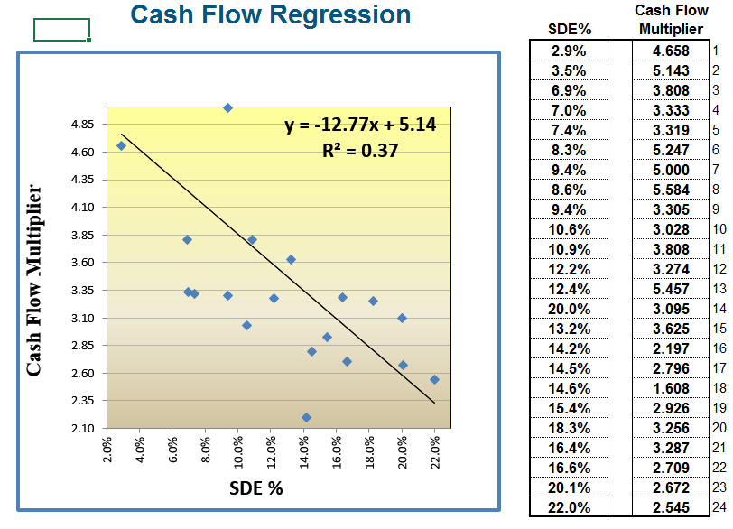

Exhibit VIII

There are two reasons for this phenomenon. The first reason is the cash flow multiplier is a ratio of the selling price divided by a company’s cash flow (the denominator). A company with a very low level of cash flow will have a small number in the denominator of the ratio. Hence, the small denominator in the ratio creates a large multiplier. Conversely, a company with a high level of cash flow will have a large number in the denominator of the multiplier ratio which will yield a smaller multiplier.

The second reason is that there is a decreasing return to value as cash flow increases. Companies of similar size and in similar industries typically generate more value for their first $50,000 in cash flow than they do for their last $50,000. In other words, as companies increase in profitability, their cash flow increases at a faster rate than the corresponding selling prices of businesses. For example, in the exhibit I we find the five least profitable transactions had selling prices averaging $270,000 and average cash flow of $70,000. The five most profitable transactions had an average selling price of $634,000 and average cash flow of $223,000. Moving from the lowest profitable companies to the highest we find that their average selling prices increased by 2.3 ($634,000 / $270,000). However, their cash flow increased by 3.2 ($223,000 / $70,000). Since cash flow increases as a faster rate than selling prices, the corresponding cash flow multipliers (selling price / cash flow) tend to decrease.

Before you say, “that just can’t be,” remember a company with an impressive 6.0 cash flow multiplier but $10,000 in cash flow is only worth a meager $60,000. However, a company with a paltry 2.5 cash flow multiplier and $200,000 cash flow is worth $500,000. Remember, it is not the multiplier so much as the level of cash flow that drives the value of the businesses. If you look carefully at the comparables in Exhibit II, you will note that most of the unprofitable companies had larger cash flow multipliers, yet their selling prices were still quite low. You will also note that as we move down the list of transactions in that table both selling prices and total cash flow for each transactions tend to increase. That is the logic that we all understand, i.e., the higher the cash flow the higher the selling price. However, we use ratios in our valuation calculations. The cash flow multiplier is a ratio and that ratio tends to ***decrease*** as we move down the list of transactions.

Conventional Market Approach methodologies do not capture the inverted relationship between a company’s cash flow multiplier and its level of profitability. Hence, the inverted relationship is the reason for the problems we saw among the companies in the three examples at the beginning of this article. The inverted relationship causes *median* cash flow multiplier values to dive way under the *median* revenue multiplier values in underperforming companies, and, conversely, *median* cash flow multiplier values to rise well above *median* revenue multiplier values in high-performing companies.

To finish up with our valuation of the highly-profitable company, we went through the same two-step regression process to eliminate outliers as we did for the revenue multiplier. The resulting cash flow multiplier for the sample calculated by the regression’s linear equation was 2.85 (-10.51 x .183 + 4.77).



The table at the left summarized the values that were calculated using regression versus the values calculated using the median of the sample. The regression’s cash flow multiplier is moderately below the median multiplier of 3.30; however, if we multiply 2.85 times our subject’s $220,000 cash flow, the value would be $627,000, which is fairly close to the $648,000 value calculated from the revenue multiplier. As we saw in example #3 for this company, the median cash flow multiplier value was $726,000 and the median revenue multiplier value was distant $504,000.



For the low-profit company seen in example #2, we will apply its SDE% to the same regression formula that was calculated for the high-profit company. The values that were produced are summarized in the table to the left. The subject’s cash flow multiplier was 4.02 (-10.51 x .071 + 4.77) which was considerably higher than the median of 3.30. However, the high multiplier applied to a low level of cash flow yielded a low value that was in line with the value calculated by the regression revenue multiplier.

**From the two examples above we can see that for companies that are at the opposite ends of the profitability spectrum, the regression methodology produces far more reasonable and defensible values than the median multipliers produce**.

Other Important Considerations When Using Regression

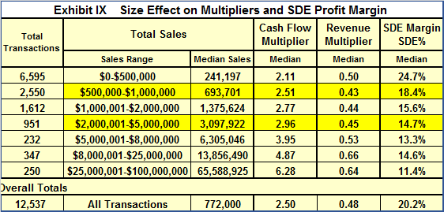Using a company’s operating profit margin (SDE%) as an indicator of its multipliers involves several considerations. First, the revenue range of the transactions that are selected should be fairly narrow and the average revenue for the sample should be fairly close in size to that of the subject. From the analysis[2] in Exhibit IX, we can see that the cash flow and revenue multipliers tend to increase with the size of the company. Therefore, using a sample of $2 million dollar companies to compare to a $500,000 company would more than likely overvalue the subject. The balance sheets, income statements, and all the operating ratios for $2 million companies are significantly different than for $500,000 companies. As such, companies that are either significantly larger than or significantly smaller than the subject are not relevant comparables.

We also see from Exhibit IX that the operating profit margins (SDE%) decrease as the size of the companies increase. This occurs because in smaller companies, the owner typically manages all facets of the company himself. He is the salesman, marketing manager, HR manager, and bookkeeper. All the profits flow to the owner to compensate him for all these jobs. As we see from Exhibit IX, a $500,000 company would generate cash flow at an average of 24.7% for every dollar of revenue, or $123,500. Also, $500,000 companies sell for an average of 2.11 times their earnings, which would suggest a selling price of $260,585.

For this company to grow to $2 million, however, the owner must now hire a bookkeeper, an HR manager, and possibly a CFO. The company is now too big for the owner to do everything himself. A $2 million company typically earns $294,000 in discretionary earnings ($2 million x 14.7% [from Exhibit IX]). Thus when a company grows from $500,000 to $2 million, the additional $1.5 million in sales added $170,500 in earnings which only yields an SDE% of 11.4% ($170,500 ÷ $1,500,000).

Thus, the $2 million company in the above example produced higher levels of gross revenues and discretionary earnings yet earned a lower SDE%. The importance of this peculiarity is that in using SDE% to predict the multipliers of a business, it becomes increasingly important to select a sample of comparables that are as close in revenue size to the subject as possible, and that are from similar SIC classifications. Otherwise, we might look at the 24.7% SDE% of a $500,000 company and draw the false conclusion that it deserves better market value multipliers than the $2 million which only produced an SDE% of 14.7%.

If your first selection for a sample of comparables contains more than 30 or 40 transactions, you might consider reducing the revenue range you used. For example, if your subject produced $1,500,000 in revenue and your first selection of 40 comparables had a range of $500,000 to $3,000,000, you should consider narrowing the range to, say, $1 million to $2 million in revenue. **A small homogeneous sample of 15 to 20 transactions will generally be far more statistically relevant than a diverse sample of 40.**

If the subject is reasonably profitable, the selected sample should not contain companies with negative cash flow or very low-level cash flow (companies with cash flow multipliers greater than 10.0). Companies that do not produce sufficient cash flow to pay debt service on a loan or the owner’s salary are generally not sold on the basis of cash flow, but rather, the value of their hard assets. Hence, their cash flow and revenue multipliers are not relevant comparisons to the subject. Conversely, if your subject is not profitable, you should consider selecting comparables with operating losses or very low-level cash flow (cash flow multipliers greater than 10.0).

The overall objective in selecting comparables is to find those companies that are **relevant** comparisons. This is not “cherry picking.” Real estate appraisers would never consider comparing a 5,000 sq. ft. house to a 1,200 sq. ft. house, or a $2 million house to a $300,000 house. They are completely different assets with different sq. ft. prices. The appraiser is the expert and it is his opinion as to what is a relevant comparison.

If the reader would like to see an easy step-by-step tutorial on how to use Excel’s regression utility to calculate multipliers, I invite you to go to the “Pricing Services” page of my website: [www.affordablebusinessvaluations.com](http://www.affordablebusinessvaluations.com) and click on the link “Installing Excel and Using its Regression Utility.”

1. The measure of cash flow used in the examples is known as “Seller’s Discretionary Earnings,” or SDE. This is a measure most commonly used for valuations of smaller companies with revenues under $5 million. It is normalized EBITDA + one owner’s total compensation. The operating profit margin using SDE is notated as SDE%.
2. Data was taken from the Pratts Stat’s database. The database was filtered by removing all stock sales, transactions with operating losses, or cash flow multipliers greater than 10.